Assignment

- Build an image based on Jupyter Notebook (jupyter/minimal-notebook) with Pandas installed (pip install pandas)
- Create a container from this image and use the NOTEBOOK_ARGS=--port=8889 environment variable to change the port Jupyter is exposed on
- Verify you can access it on port 8889 and that Pandas is installed (type import pandas in a notebook).

Solution

- Create a folder for our image.
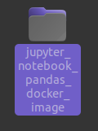

- Create Dockerfile using nano.

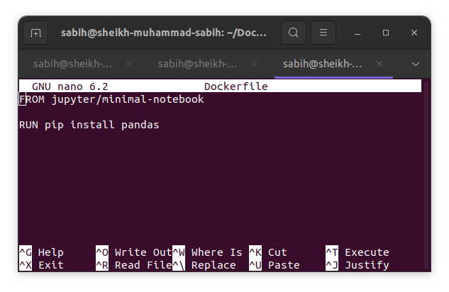
- Then write some instructions in Dockerfile to use image of jupyter/minimal-notebook and install Pandas in it.

- Then I build that docker file using docker build give it a tag jupter_notebook_with_pandas.
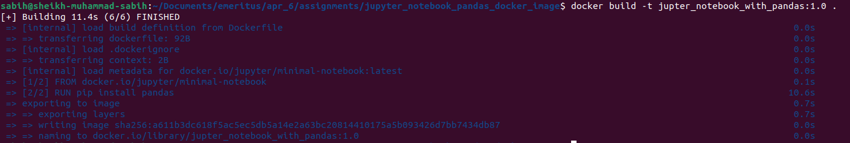

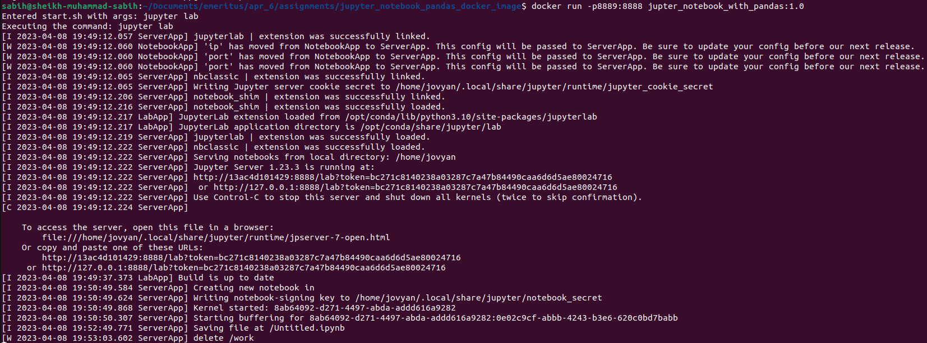
- Then I run that image in docker container on host port 8889 by using docker run -p8889:8888 jupter_notebook_with_pandas:1.0 and check the status of process status.

- To ensure that everything is working fine I run the given localhost url (http://127.0.0.1:8889/lab) with port 8889.

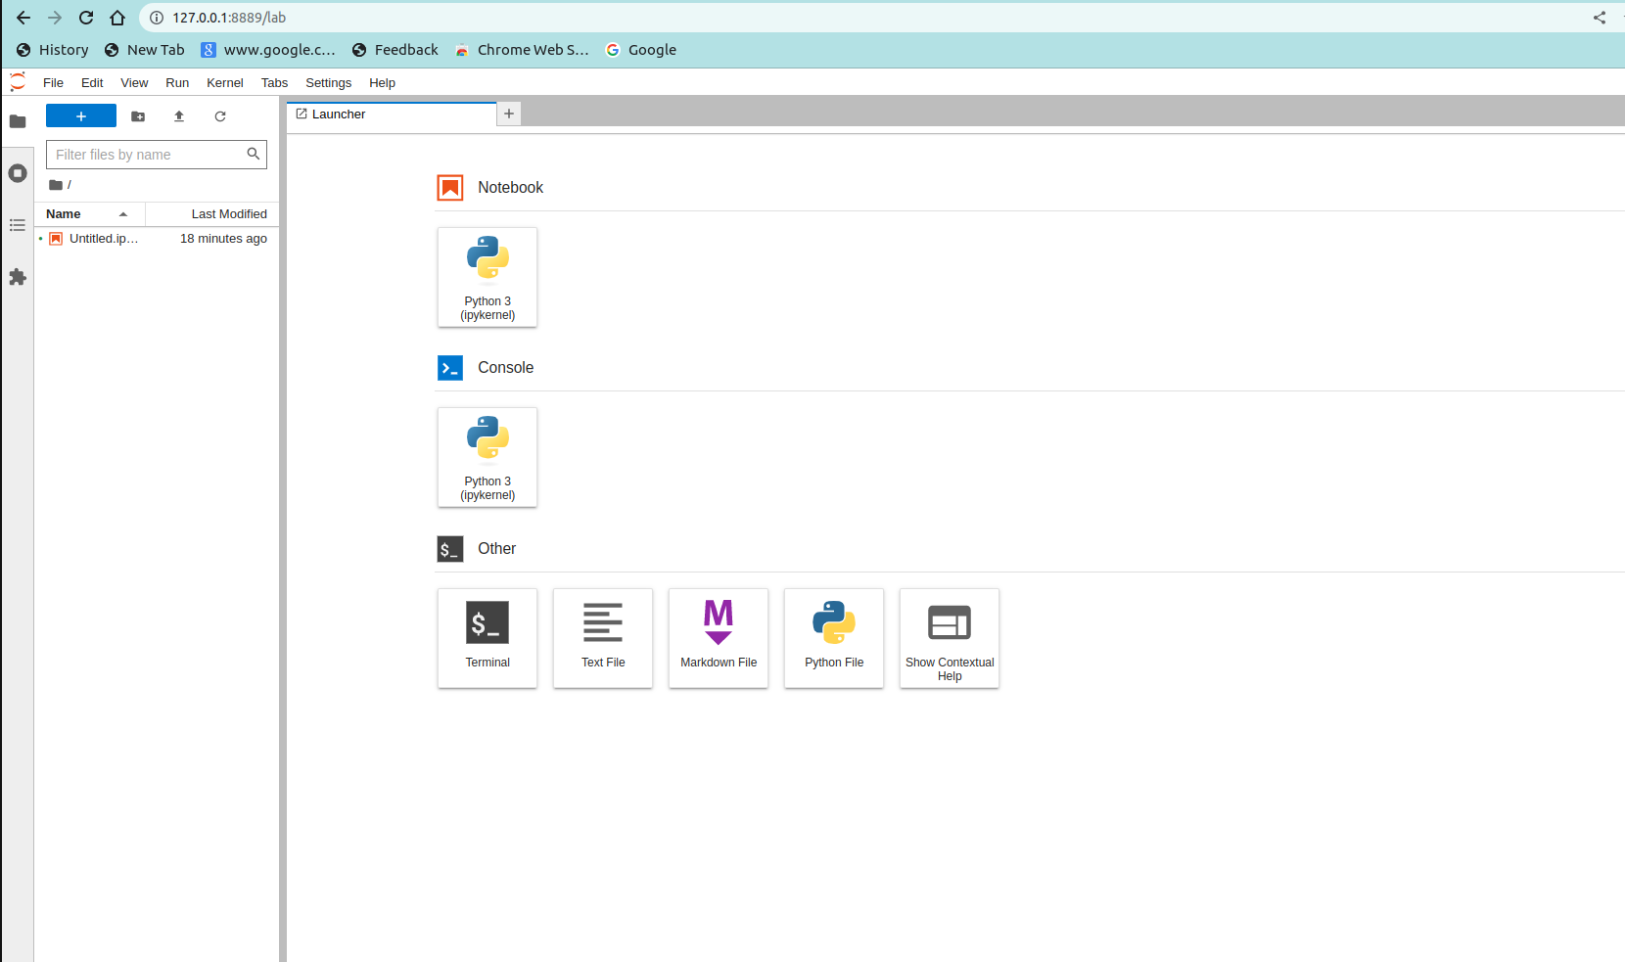

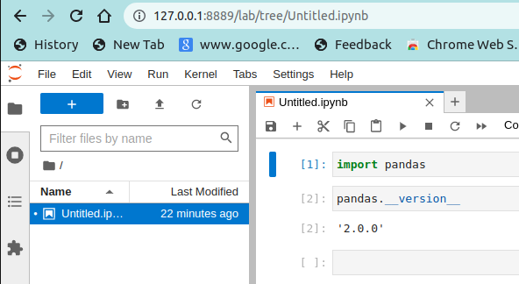
- To check pandas is install or not I write import pandas and pandas.__version__.

